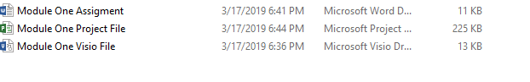

**Visio screen shot**

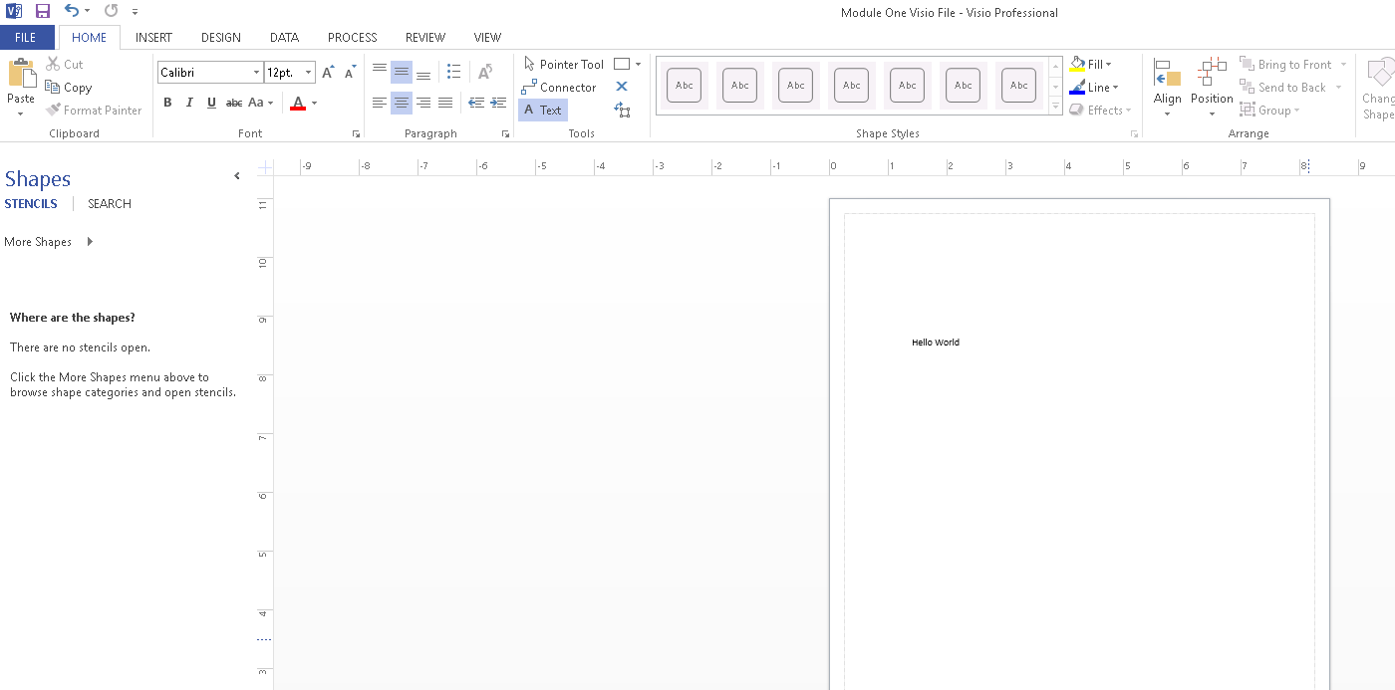

**Project Screen shot**

